Sunny –

I have listed out below modifications to a few of the charts I am hoping to implement. Now that we’ve finished creating all the possible charts, I’d like to take a pass through from the top and make some small modifications to tighten things up a bit. Then we can continue onwards to building the actual website.

**Chart 1 (primary CSI chart) –**

1 - Default values shown on chart upon initial load:

Can the values displayed when the chart first loads be changed to:

Both CSI lines

Volatility Forecast

Gridlines

In other words, the ones that would need to be optionally switched on will be S&P 500, and both volatility bands.

2 - Can the name change in the legend for the S&P 500 be changed from SPY to “S&P 500” please?

3 - Can the individual position of each axis be rearranged? I labeled each axis position as 1, 2 or 3 in the screenshot below just to make things easier to refer to.

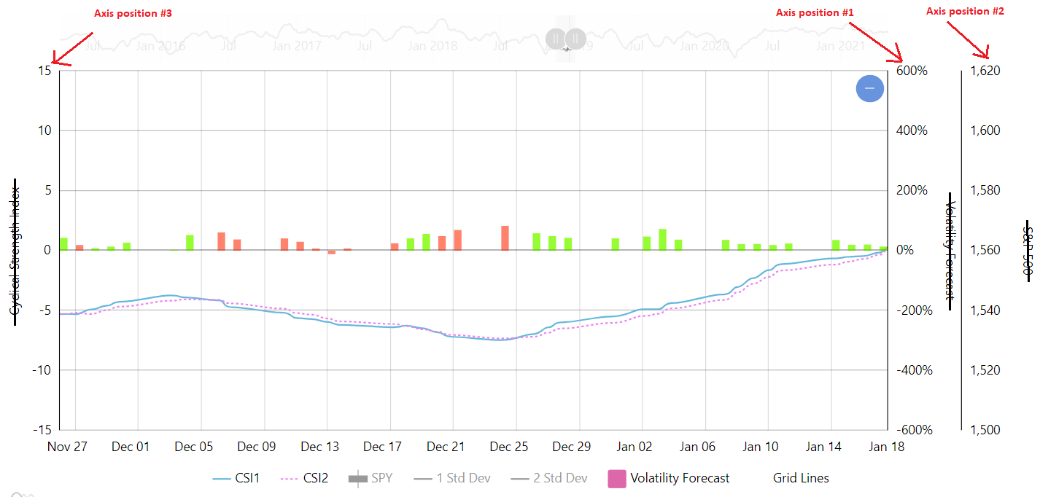

Can axis position 1 be CSI, axis position2 be Volatility Forecast and axis position 3 be the S&P 500?

4 - While we’re at it, can the label of each axis be removed? I’m thinking this will free up space on the chart. I looked at the example online, and their example does not use labels on each axis yet it still looks clean.

5 - Additionally, is it possible to change the color of one axis? In their example (<https://www.amcharts.com/demos/multiple-value-axes/>), instead of labeling each axis, they have each colored to match the line color. That won’t be exactly possible for our version, since each data series utilizes multiple colors… but can the axis color for CSI be set to match the same blue color as the CSI1 line?

6 - Axes zoom feature…

Also, I believe our chart axes aren’t adapting as much as they could when the user decided to adjust the zoom feature. Please see the screenshots below:

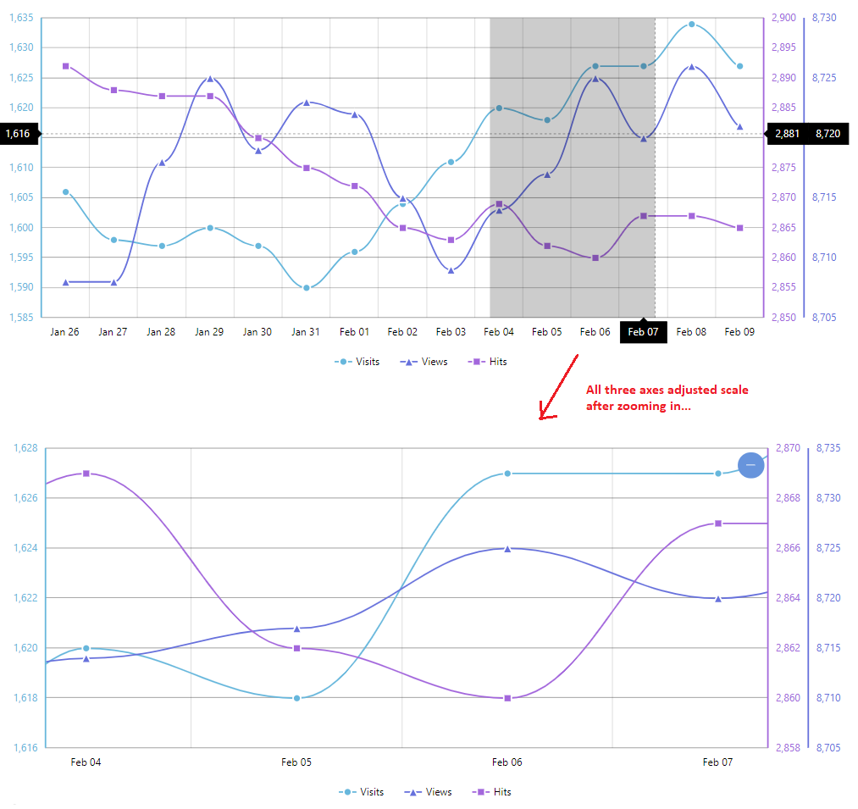

The amcharts example is able to have each of its three axes adapt to different scales when the user decides to zoom in on a particular point of time. However, on our chart, only the S&P 500 axis adjusts scale as the user scrolls through various points in time. Both the CSI and Volatility Forecast axes remain locked at a single scale that I believe encompasses the min / max values for the entire historical time duration. Can the CSI and Volatility axes please be “unlocked” so that their scale will also adapt as the user play with the time/zoom of the chart?

7 - Default zoom of chart

Is it possible to set the default zoom of the chart for when it first loads to only the most recent 4 months? The older chart currently on <http://williamgorfein.com> is set this way, and I believe its set by “pre zooming” the axis using the following instructions: <https://www.amcharts.com/docs/v4/tutorials/pre-zooming-an-axis/>

8 – Can the tooltip for S&P 500 be changed so that it only displays data for the “close” value? (therefore, open, high, and low would no longer be show in the tooltip).

**Daily Averages Chart -**

Can the names on the legend be changed to:

Daily PnL  
Daily Volatility   
Sharpe Ratio

Legend placement - can the legend placement be moved to the top of the chart just like in the following example and screenshot below? (https://www.amcharts.com/demos/clustered-column-chart/)

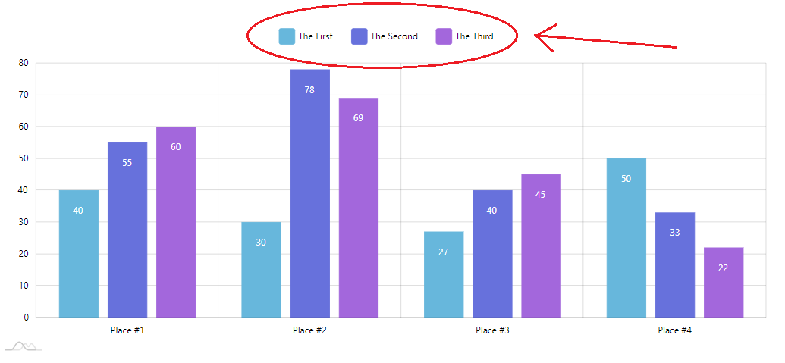

Lastly, and I’m not sure if its possible… can a colored square be placed to the left of each piece of text in the label? The desired look would be like the screenshot below:



I’m unsure if this is possible, but would be desirable, if doable.

**S&P vs Quadrants Historical Returns Comparison –**

Can the legend placement be moved to under the chart (as opposed to the side)?

**Quadrant Fat Tails chart-**

Can the data series shown when the chart loads be: Quadrant 1, Quadrant 2, Quadrant 3 and Quadrant 4? (therefore, S&P 500 and Black Scholes would not be displayed until user clicks on them in the legend).

Additionally, can the legend placement be moved to under the chart?

**KDE chart –**

1 – Changing zoom feature

Can the zoom feature be changed to the following more simple version as shown on the following chart?... <https://www.amcharts.com/demos/trend-lines/>

2 – Data series to remove

Can this chart now only graph the single KDE Score line? Therefore, the KDE Score Avg and Difference lines will be removed. This would also change the line graph to a simple single line graph instead of being a double line graph with multiple axes.

**Charts to remove:**

Animated predicted accuracy chart

Expected returns

I know these took a good amount of time, especially the animated version, but I think the information of them is already being communicated elsewhere in other charts and that by removing these two, we can make the page a bit simpler to display information and load.